HW Subsystem Test Plan
Sensor board is not connected to the Microcontroller-board, References: HW_Testing.docx (PM3), Checklist_Marks.xlsx (PM4)
Test item, Description | Test Conditions | Expected, Tolerance | Measured Result | Comparison, Verdict | Remarks, Discussion
Signal Gain-Phase  - w/o radar sensor  - on I- and Q-paths | Sine input signal:  50 uVpp & 1mVpp  10 Hz … | Gain in passband:  … dB ± … dB  cut-off frequencies LP/HP: … | Scope  Option: Bode Plots  (see example) | passed / as designed  not passed | …
DC level
- w/o radar sensor
- on I- and Q-paths
- after each Amp
Radarsignal Gain-Phase  - on I- and Q-paths | Radar Doppler Target K-DT1 with f_{d} = …  at distance … | I/Q-Gain-Difference  …  I/Q-Phase difference 90° ± … | Scope Channel A/B
Additional Features

Example: Frequency Response Bode Plot (PicoScope 2206B: https://www.picotech.com/downloads,
3rd party WINDOWS app: FRA For PicoScope: https://bitbucket.org/hexamer/fra4picoscope/wiki/Home)
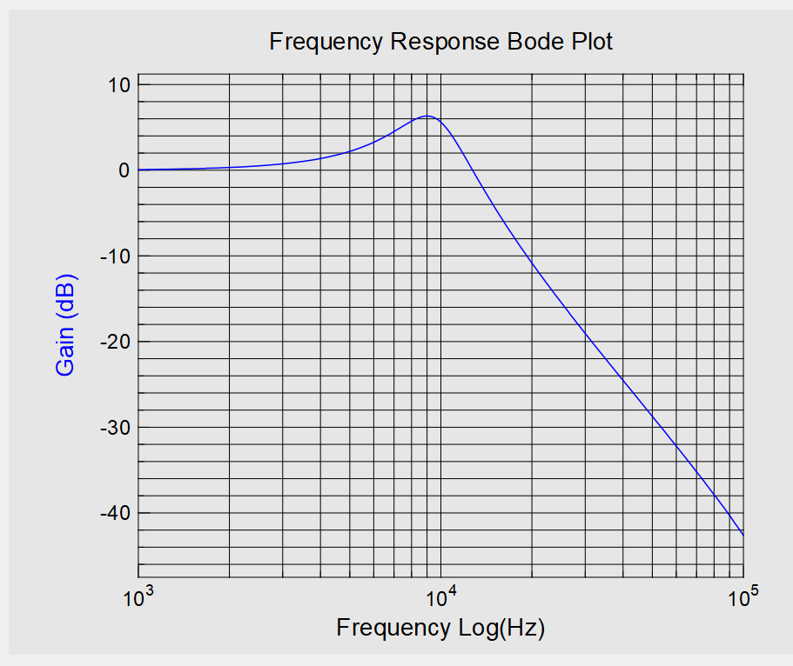
FW Subsystem Test Plan
Microcontroller-board is not connected to the Sensor board, References: HW_Testing.docx (PM3), Checklist_Marks.xlsx (PM4)
Test item, Description | Test Conditions | Expected, Tolerance | Measured Result | Comparison, Verdict | Remarks, Discussion
ADC Samples  - on I- and Q-paths | no signal  … | DC-value of virtual GND  … |  | passed / as designed  not passed | …
FFT output  - on display | Sine input signal:  … Hz, … Vpp | peak and leakage
Frequency / Speed  - w/o sign!  - on I- and/or Q-paths | Sine input signal:  … Hz, … Vpp | Frequency +… ± Δf/2  (Δf = fs/NFFT) | speed or frequency without sign
Frequency / Speed  - with sign | sin/cos signals from Matlab and USB-Audio Interface: … Hz, … Vpp | Frequency … ± Δf/2  (Δf = fs/NFFT) | speed or frequency  with sign
Additional Features

